INVENTORY

OF

FURNITURE, FITTINGS AND EFFECTS

AT

17a COSWAY STREET

LONDON NW1 5NR

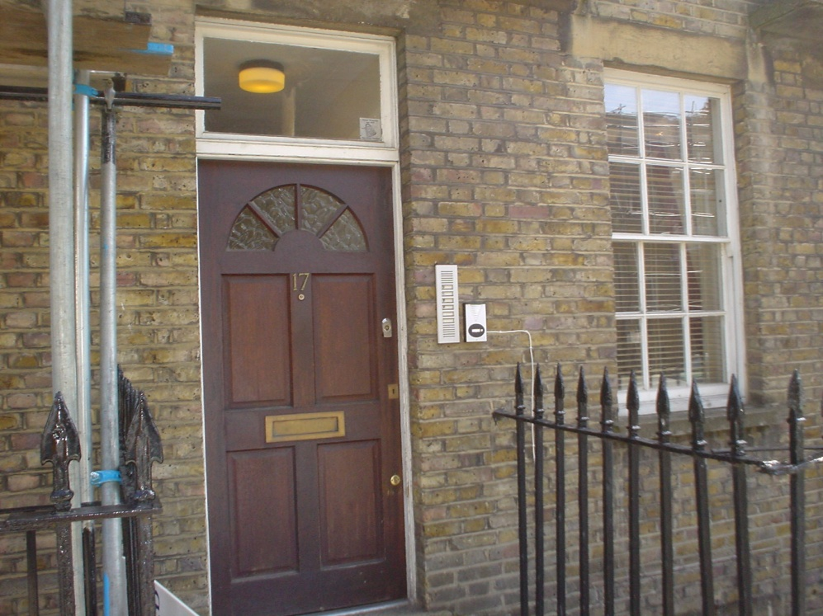

[………/….]
I N D E X

FRONT DOOR 4
ENTRANCE HALL 5
BEDROOM 6
BATHROOM 8
OPEN PLAN LIVING ROOM AND KITCHEN 10
OPEN PLAN KITCHEN AREA 10
SCHEDULE OF CONDITION 14
METER READINGS 15
SIGNING SHEET 16

PLEASE NOTE
♦ This inventory relates only to the furniture, furnishings and effects in the property. It is an independent report describing the contents, the condition and the cleanliness of the property for rental purposes.
♦ Please note that all electrical items and appliances are not tested. This includes washing machines, dryers, fridges, vacuum cleaners, ovens, hobs, etc..
♦ We cannot undertake to move heavy furniture, or search in inaccessible places, such as high level cupboards, lofts or basements.
♦ This inventory has been prepared on the principal that all items are in good, clean condition. If not, any defects, damage or soiling is listed in the right hand column.
THE CHECK - OUT
♦ The inventory will be fully checked at the end of the tenancy. All personal possessions must be removed prior to the check-out, and the property must be ready for the check-out. Failure to do so may result in an abortive visit together with an additional fee being charged .
♦ All furniture and items must be left in the same places as listed in the inventory. Any items stored during the tenancy must be unpacked and returned to their original places. If items are not returned to their original places and are therefore not found at time of check - out, you may be charged for these items.
♦ The property should be left in a clean and tidy condition to a professional standard at the end of the tenancy. We suggest you refer to your tenancy agreement concerning terms and conditions relating to how the property should be left, especially with regard to the carpets, curtains, upholstery, etc..

FRONT DOOR
Exterior – dark wood, brass A, spyhole Yale lock and Chubb lock
Interior – to match with locks to match and security chain

ENTRANCE HALL
 | 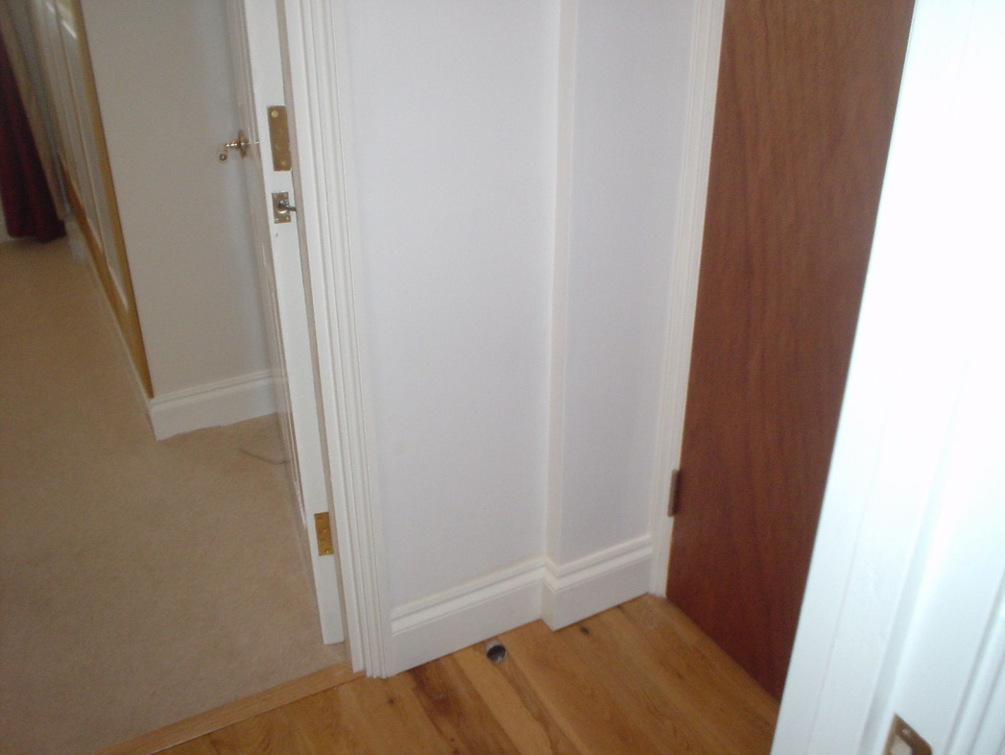
Wall mounted entry phone
Beige off cut of carpet |  | None
Light to ceiling with glass dome shade
Wall mounted fuse boxes

Decorative Condition
Ceiling – white
Cornice - white
Walls – white
Skirting – white
Floor – wood block flooring
Sockets and switches - sound

BEDROOM
 | 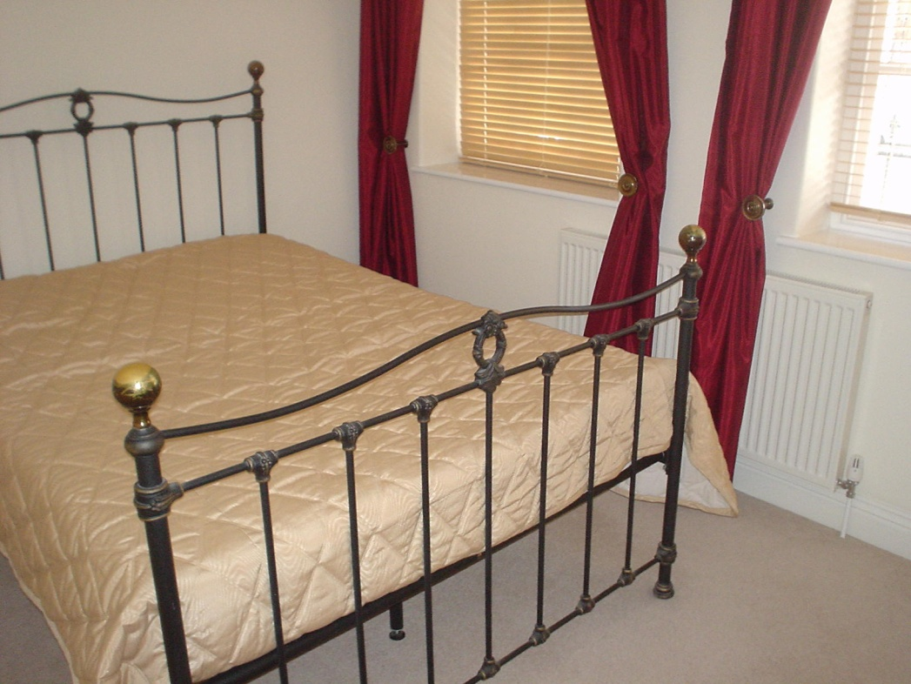
Radiators- white
Gilt light to ceiling with bulbs and crystal small drops
Double wrought iron divan and headboard
Double mattress
Double mattress protector
Double beige padded throw over bed spread |  | None
2 wall mounted brass lights with glass shades |  | One spare shade in Kitchen cupboard
2 light wood slatted blinds
Radiator – white
2 pairs of full length fully lined red slub silk curtains with brass tie backs
TV point
Ceiling mounted smoke detector
Range of light wood and white fitted wardrobes, with brass pulls to hanging rails storage space and pull out drawers
2 beige scatter cushions
2 beige cushions covers
Navy towel |  | None
Mirror in wood frame

Decorative Condition
Ceiling – white
Cornice - white
Walls – cream
Skirting – white
Floor – close fitted beige carpet | Aged
Sockets and switches - sound
Window frames - white
Glazing - sound
Catches – complete
Door – painted white with white china pulls

BATHROOM
 | 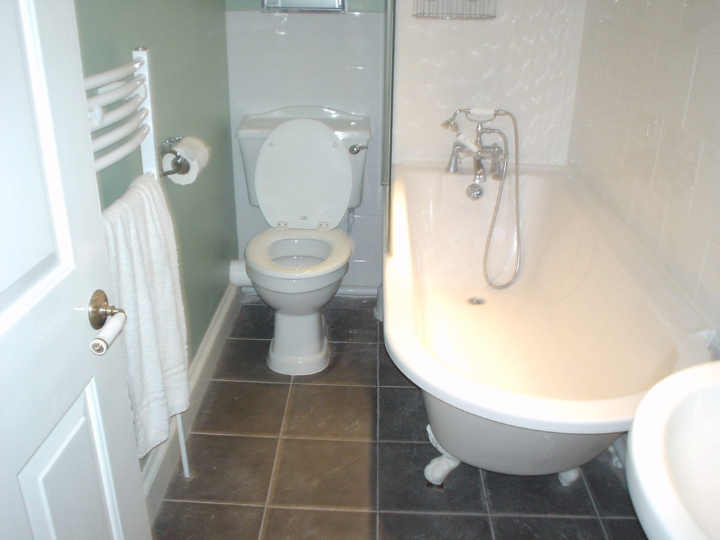
White bath towel |  | None
Wall mounted mirror panel
Wall mounted plate glass shelf
Light pull cord with chrome acorn
Wall mounted chrome beaker holder with beaker
Wall mounted chrome soap dish
White wall mounted heated towel rail
Wall mounted chrome toilet roll holder
Wall mounted extractor fan
2x Wall mounted double door chrome medicine cabinet with 2 plate glass door and pulls to storage space
3 inset spots to ceiling
White suite
Pedestal wash hand basin chrome mixer taps and pop up waste
Victorian style bath with legs, chrome mixer taps, and shower hose with head, plate glass side panels
Low level wc, matching seat and lid chrome flush handle to cistern

Decorative Condition
Ceiling – white
Cornice - white
Walls – part pale green part white ceramic tiles
Skirting – white
Floor – close fitted black slate tiles
Door – painted white with chrome hooks to interior and china pulls

OPEN PLAN LIVING ROOM AND KITCHEN
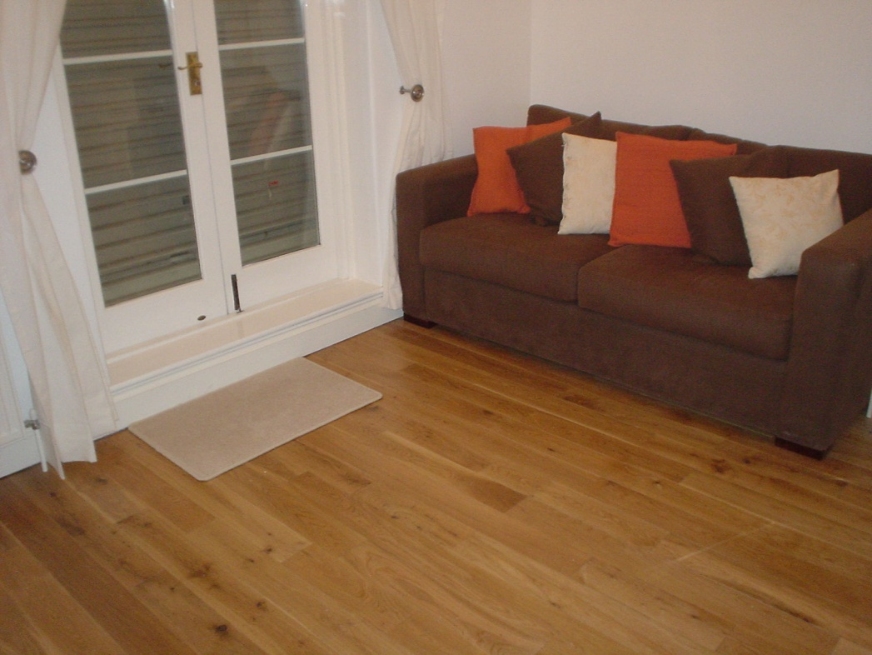
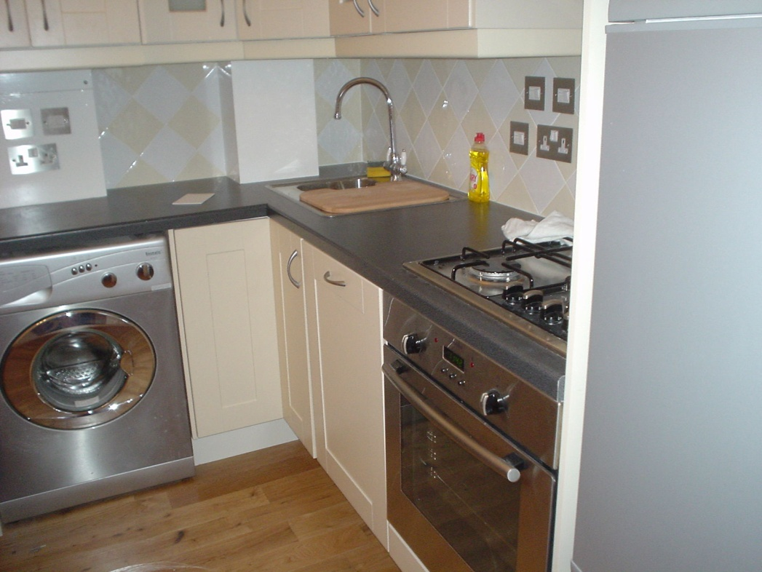

Up right Hoover vacuum with attachments | None
Pine drop down leaf dining table legs | None
2 pine dining chairs with cream seat pads | None
3 wall mounted plaster up lighters
Wall mounted cream painted shelf
Ceiling mounted smoke detector
Radiator – white
Telephone point
TV point
Pair of full length unlined cream cotton curtains hung on painted wood pole
Beige carpet mat | None
2 seater brown up holstered sofa bed with 2 loose seat and back pads
2 brown scatter cushions
2 red scatter cushions
2 beige self pattern scatter cushions

OPEN PLAN KITCHEN AREA
Range of cream laminate fitted wall and base units st steel pulls, 2 plate glass doors with 4 plate glass shelves to interior
Grey speckled laminate work surfaces
Zanussi fridge freezer
2 drawers
2 chill boxes
Plate glass shelf
2 wire racks
Compartments to door
Hinari microwave with plate glass turntable
Electrolux st steel built under oven, 2 wire rack drip tray grill pan an griddle
4 ring st steel Electrolux st steel gas hob 2 metal trivets
Electrolux st steel canopy extractor fan
Small plastic chopping board
5 wine glasses
Glass jug | None
China small bowl | None
Odd glass | None
Potato peeler | None
Grill pan handle
St steel one an half bowl sink and drainer, chrome mixer taps and 2 pop up plugs
Built in slim line dishwasher
Wood chopping board for the sink
Baumatic st steel washer dryer
Boiler to interior of units
Smoke detector to ceiling
Infra red balcony shutter control (on top of fridge)

Decorative Condition
Ceiling – white
Cornice - white
Walls – white
Skirting – white
Floor – wooden floor
Sockets and switches - sound
Double door - painted white with gazed panels, brass pulls twisting bolts and lock with one key shutters to exterior
Door – painted white with white china pulls

SCHEDULE OF CONDITION
GENERAL CONDITION - | Professionally clean, recently decorated and refurbished
SKIRTING/  WOODWORK | Recently painted
CARPETS/  FLOORING - | Clean
CURTAINS - | Clean
SANITARY WARE - | Clean
KITCHEN - | Clean
WINDOWS - | Clean
LINEN/TOWELS - | Clean
GARDEN/PATIO - | Clean

METER READINGS
GAS METER:
ELECTRIC METER
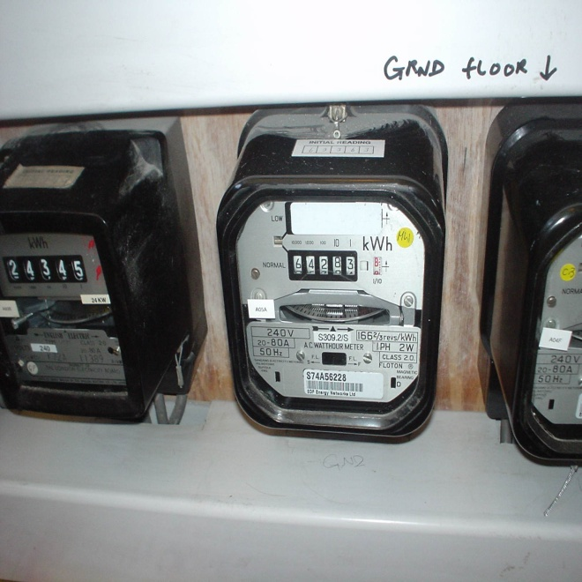 |  | 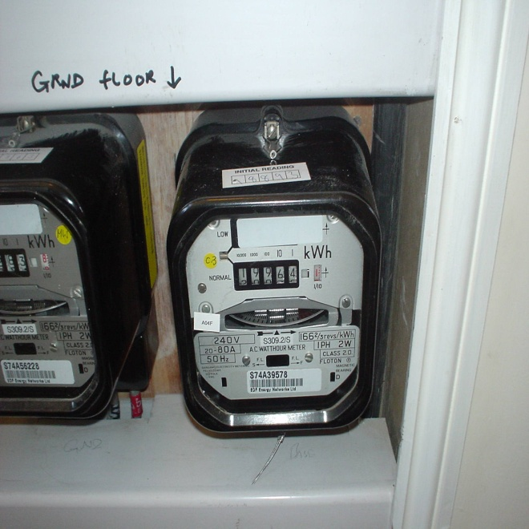
These readings must be checked by the relevant boards,
as we cannot be held responsible for any discrepancies.

We the undersigned having examined the foregoing Inventory

have found it to be correct subject to any marginal notes and comments.
............................................  ON BEHALF OF TENANT |  | ...........................................  ON BEHALF OF LANDLORD |  | .............................  DATE

THIS INVENTORY WILL BE CHECKED AT THE END OF THE TENANCY
AND ALL ITEMS SUCH AS FURNITURE, KITCHEN EQUIPMENT, LINEN
ETC. SHOULD BE READY AND IN THE SAME LOCATION AS LISTED.

